Thomas Gillett

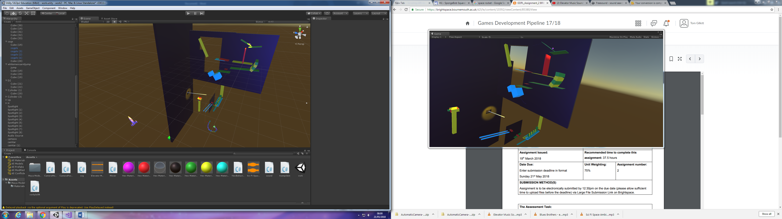

## Game Development Pipeline

## Rube Goldberg machine

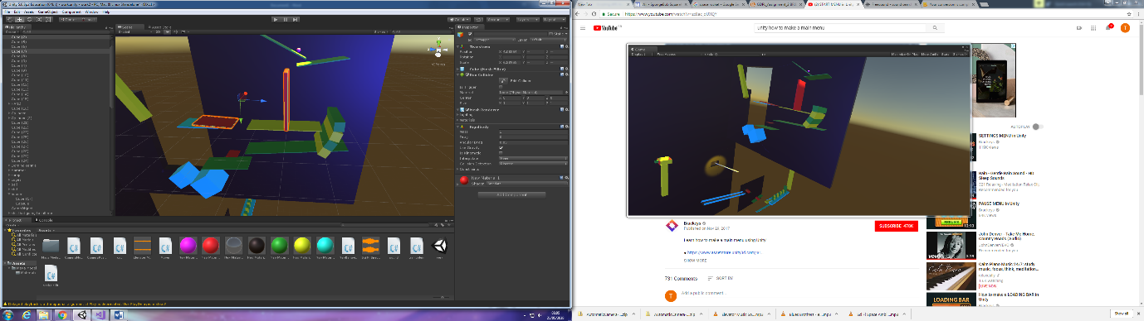

* The first device that I did was a simple domain I used the ball the push the first domain into a cube laying down this then hit that cube down. This cube will end up making a bridge for the ball when it rolls down.

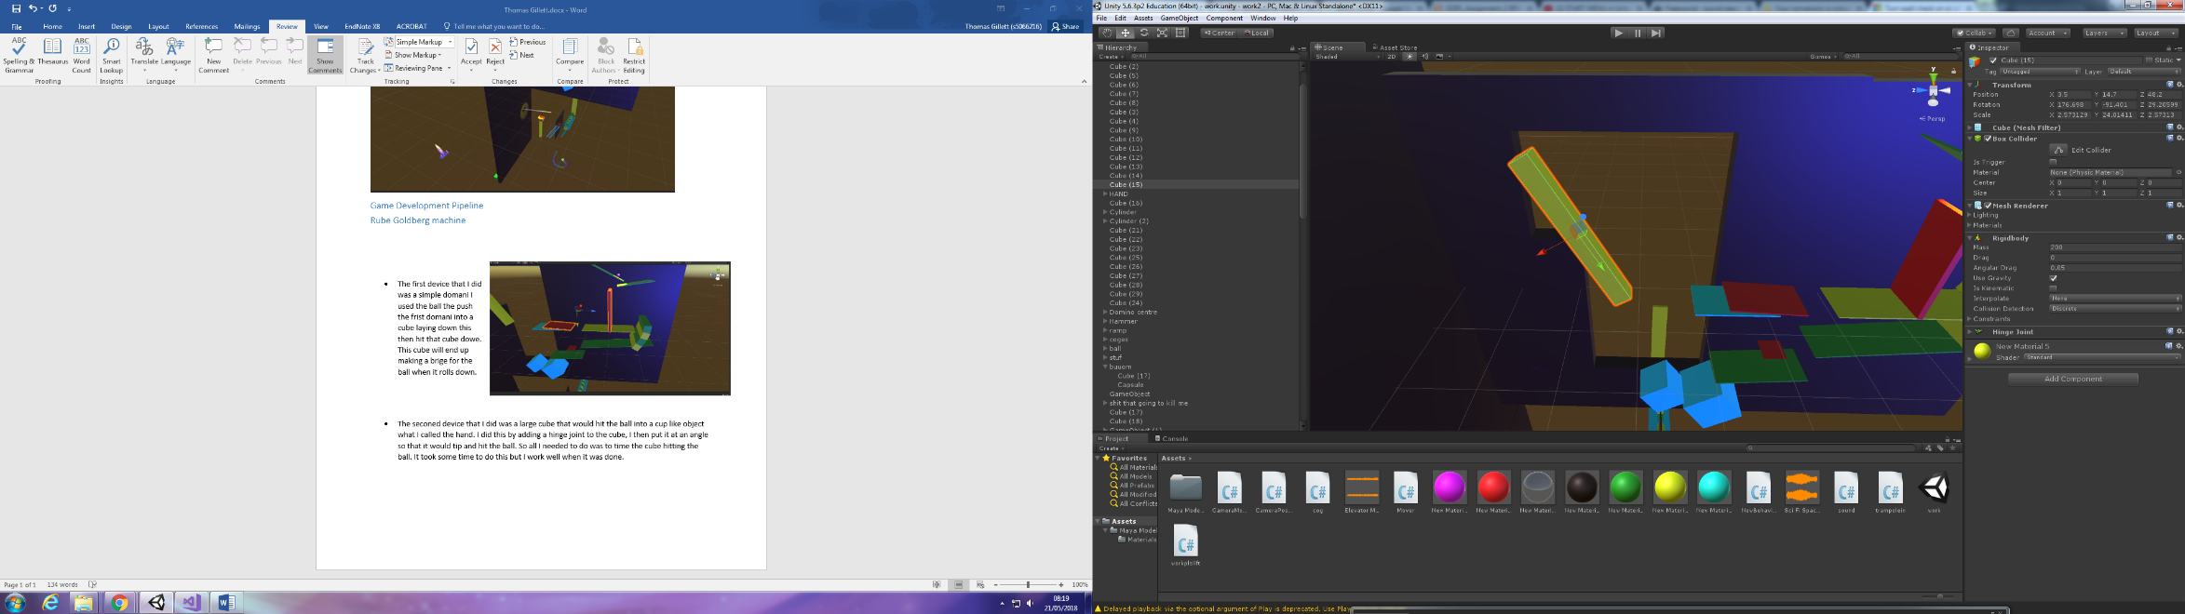

* The second device that I did was a large cube that would hit the ball into a cup-like an object what I called the hand. I did this by adding a hinge joint to the cube, I then put it at an angle so that it would tip and hit the ball. So all I needed to do was to time the cube hitting the ball. It took some time to do this but I work well when it was done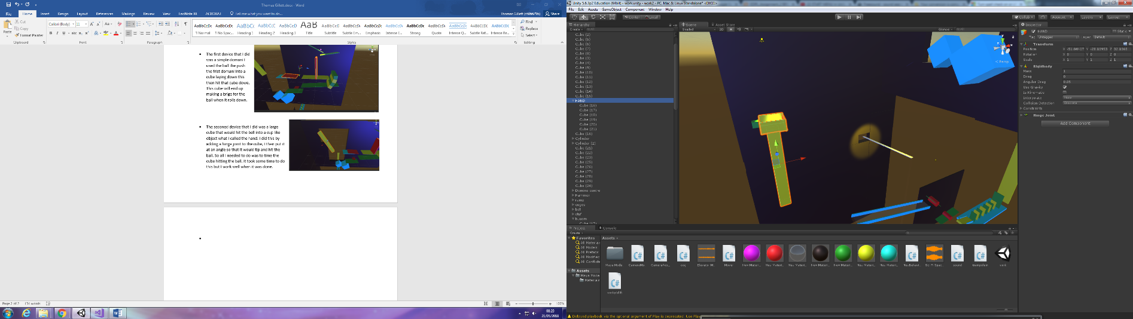.
* I made this device so that it would catch the ball form when it was hit by the cube. The ball would go into the hand then the extra weight of the ball would tip the hand down. The hand would then drop the ball on a platform below. This platform would then leed to the next device. I did this the same way as the cube hitting the ball by putting a hinge joint on the bottom left. I also used a green cube at the back, I used this to stop the hand moving before it got the ball. It took about 20 mins to get the hand in the right place so that it would catch the ball.

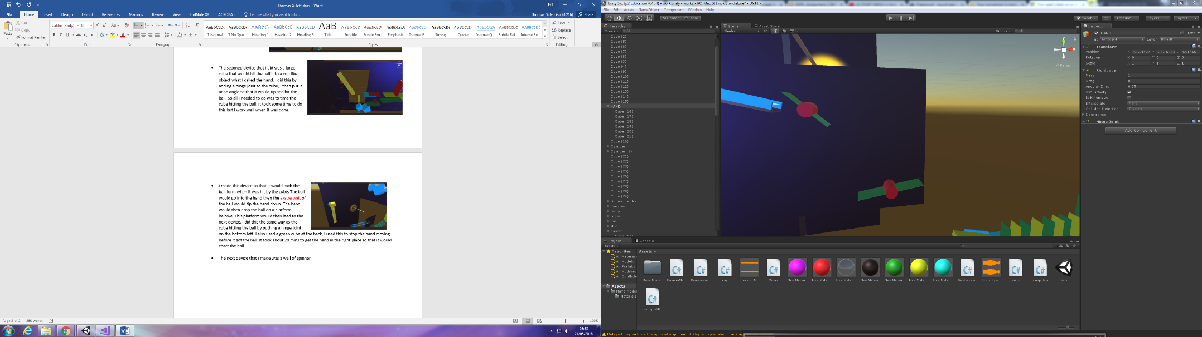

* The next device that I made was a wall of a spinner. These spinners hit the ball to the next platform. These were made by putting a hinge joint in the center, then I used the motor to make its spine. At first, they did not push the ball the way I wanted them to but I played with the numbers in the target velocity and the force, and after some trial and error I got them to work.

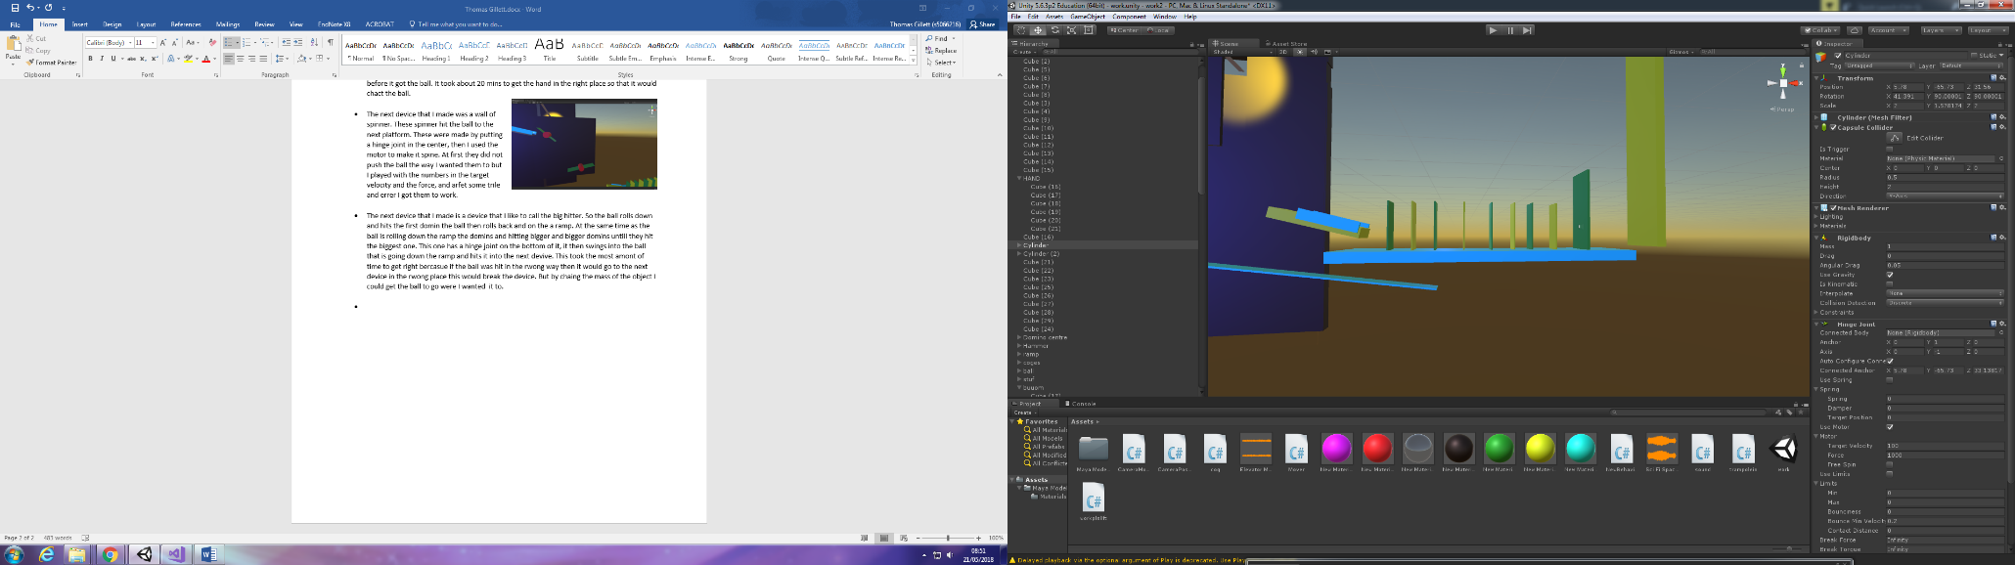

* The next device that I made is a device that I like to call the big hitter. So the ball rolls down and hits the first domain the ball then rolls back and on the ramp. At the same time as the ball is rolling down the ramp the domains and hitting bigger and bigger domains until they hit the biggest one. This one has a hinge joint on the bottom of it, it then swings into the ball that is going down the ramp and hits it into the next device. This took the most amount of time to get right because if the ball was hit in the wrong way then it would go to the next device in the wrong place this would break the device. But by changing the mass of the object I could get the ball to go where I wanted it to.
* 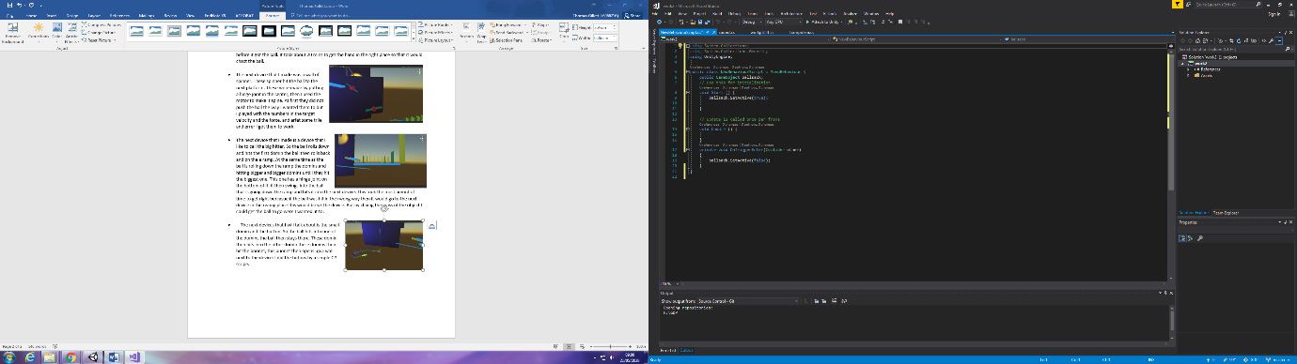 The next devices that I will talk about are the small domino and the button. So the ball hits into one of the dominoes the ball then stays there. This domino then hits into the other domino these domains then hit the button, this button then opens up a wall next to the device. I did the buttons by a simple C# script. This is the most simple script that I did. I had no problem with it at. It worked Exley how I wanted it to. What made my life much better.
* The next device that I made was the elevator. This took a lot of working out but after some time I got the C# script to work. I used a cube to trigger the cubes going up. So when to ball hit the invisible cube it would set the other cubes off.

This is the code that took the most amount of time.

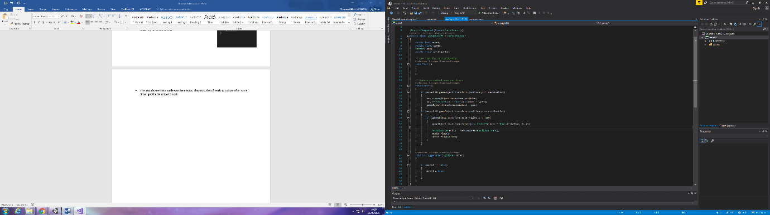if (moved && gameObject.transform.position.y <= destination)

{

pos = gameObject.transform.position;

pos += Vector3.up * Time.deltaTime * speed;

gameObject.transform.position = pos;

}

if (moved && gameObject.transform.position.y >= destination)

{

if (gameObject.transform.eulerAngles.x <= 100)

{

gameObject.transform.Rotate(new Vector3(speed * Time.deltaTime, 0, 0));

The first six times I did this I would not work but I vilsed that it was bacasue of this code.

if (moved == false)

{

moved = true;

as you can see its simple be the fist cuple of times I did this I whrite

if (moved false)

{

moved true;

It’s a simple mistake but as you know stuff like this still brakes the whole thing. Then the ball gets to the top of the elevator it then turned the ball into another ramp this ramp leads into the next device.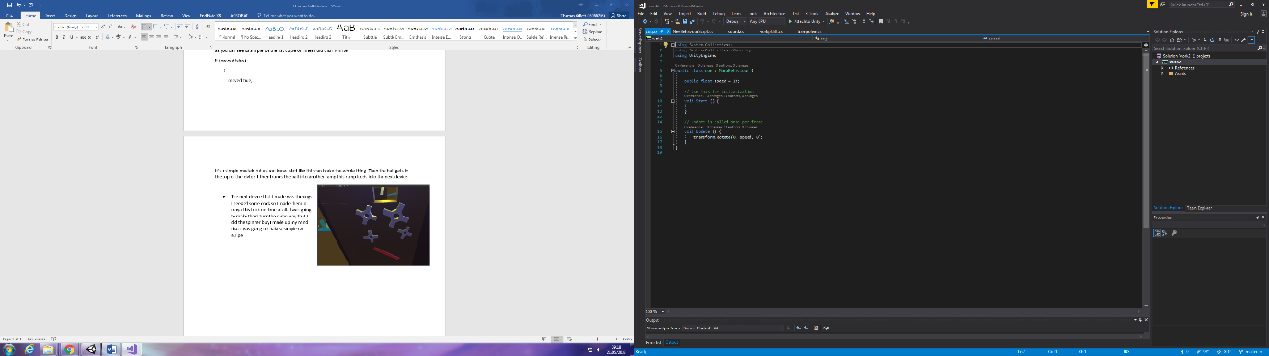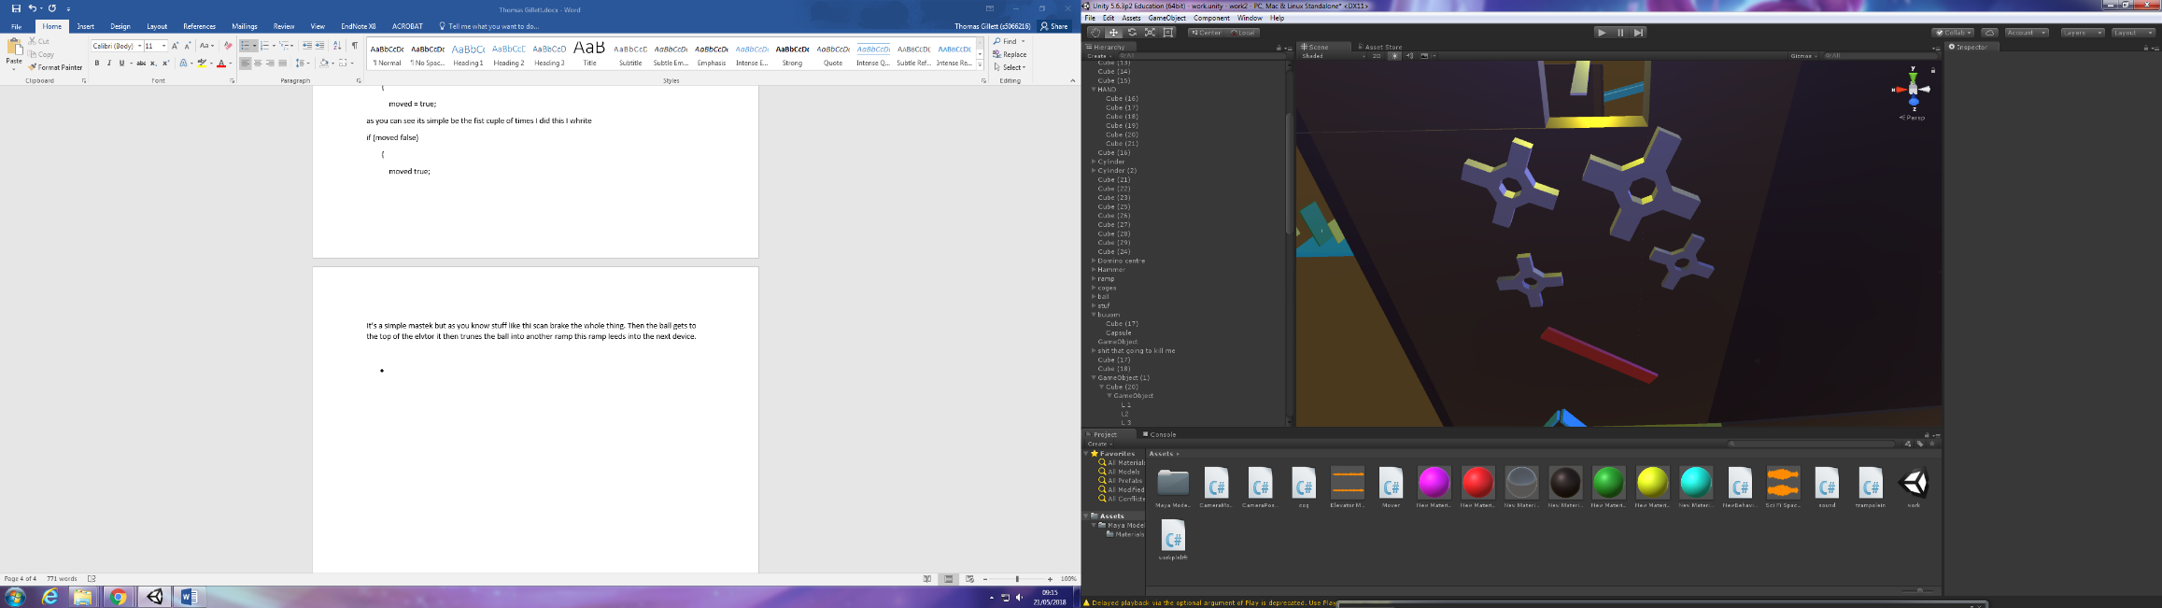

* 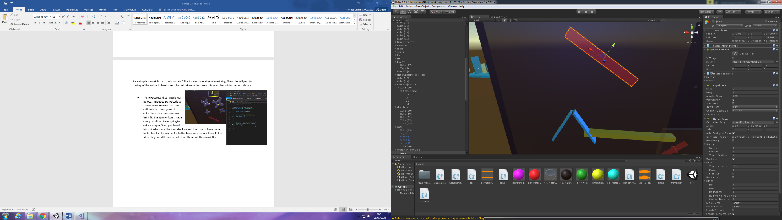The next device that I made was the cogs. I needed some codes so I made them in Maya this took no time at all. I was going to make them turn the same way that I did the spinner buy I made up my mind that I was going to make a simple C# script. I used this script to make them rotate. I wished that I could have done the hitbox for the cogs a bit better because as you will see in the video they are a bit broken but other than that they work fine
* The next device that I made was a red cube that hit the ball in the right way this was very simple it just a simple hinge joint with a motor. It is very simple but it does what it needs to do.

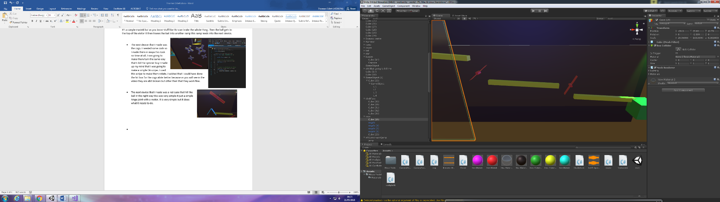

* The next device is some more spinner I used these so that I could get the ball to move faster do the ramp. I did these the same way I did the other with a hinge joint and a motor.

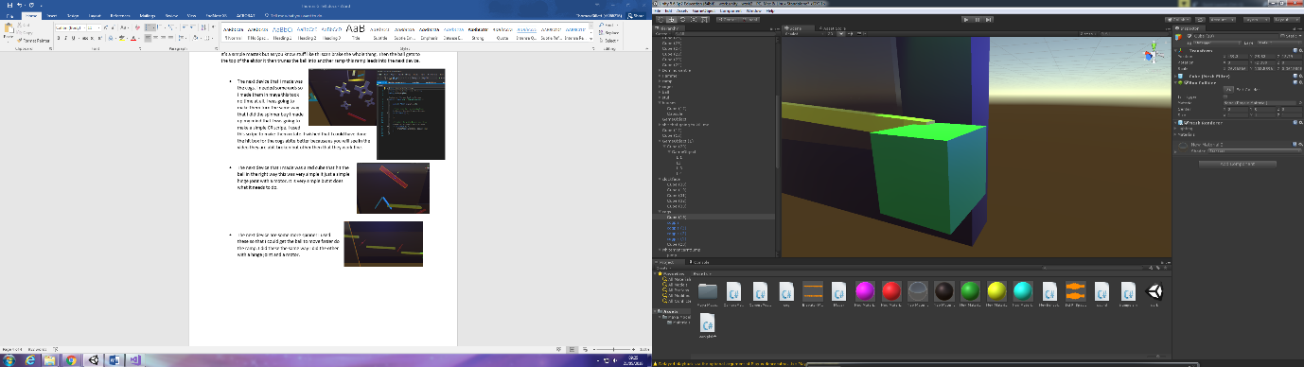

* The next device that I made was a trampoline I made this by using C# I made this code

float Jumping = 20;

public Rigidbody actor;

// Use this for initialization

void Start () {

actor = GetComponent<Rigidbody>();

}

void OnCollisionEnter(Collision collision)

{

if (collision.gameObject.name == "goup")

{

actor.velocity = new Vector3(0, Jumping, Jumping);

}

I'm happy with this piece of code and to be honest I'm happy with all my code, I have never been that good with code, but it has all seemed to turn out nicely. This cube will jump the ball when it comes in contact with it. This ball will then fly into a rocket this rocket will then fly off.

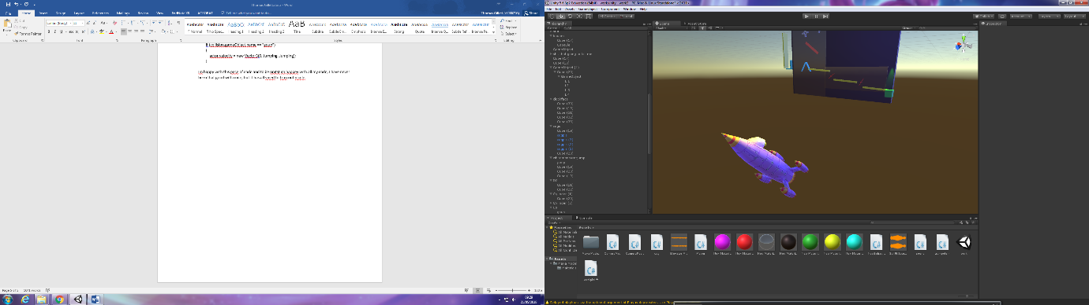

References

lemurboy12, 2018. *spongebobsquarepantscreaturefromthekrustykrab.* [Online]   
Available at: https://www.models-resource.com/wii/spongebobsquarepantscreaturefromthekrustykrab/model/17949/  
[Accessed 21 may 2018].

Productions, A., 2014. *Youtube.* [Online]   
Available at: https://www.youtube.com/watch?v=vxWhxA8nfH8  
[Accessed 21 may 2018].